* **Unit/Integration Test results after fixing the reported first bug: -**

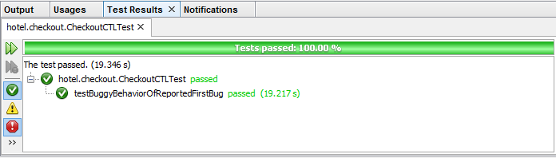

## Figure 1

* **Output of the system after fixing the reported first bug: -**

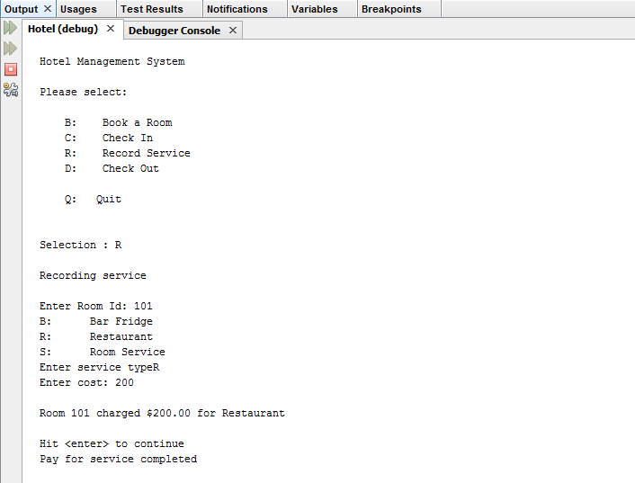

## Figure 2

